**Pizza Sales Project**

**SQL Queries**

**KPI Measures**

* Total Revenue

Syntax : select sum(total_price) as Total_Revenue from pizza_sales

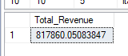 OUTPUT:

* Avg Order Value

Syntax : Select Sum(total_price)/count(Distinct(order_id)) as Avg_Order_value from pizza_sales;

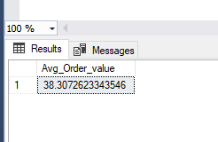 OUTPUT:

* Total Pizza Sold

Syntax : select sum(quantity) as Total_Pizzasold from pizza_sales;

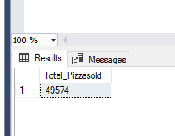 OUTPUT:

* Total Orders

Syntax : select count(distinct(order_id)) as Total_Orders from pizza_sales;

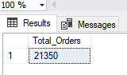OUTPUT:

* Avg Pizza Per Order

Syntax : select cast(cast(Sum(quantity) as decimal(10,2))/cast(count(distinct(order_id)) as decimal(10,2)) as decimal(10,2)) as Avg_Pizza_perOrder from pizza_sales;

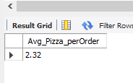OUTPUT:

* Daily Trend for Orders

Syntax : select datename(DW,order_date) as order_day, count(distinct(order_id)) as Total_Orders from pizza_sale group by datename(DW,order_date)

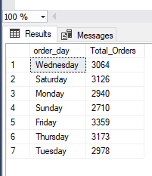OUTPUT:

* Monthly Trend For Orders

Syntax : select datename(Month,order_date) as Month_name, count(distinct(order_id)) as Total_Orders from pizza_sale group by datename(Month,order_date) order by Total_Orders desc;

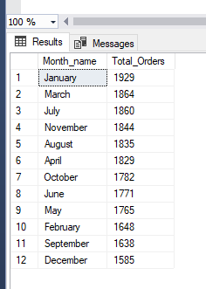OUTPUT:

* % of Sales by Pizza Category

Syntax : select pizza_category,Sum(Total_price) as Total_Price, sum(total_price)*100 / (select sum(total_price) from pizza_sale) as Total_Revenue from pizza_sale group by Pizza_Category;

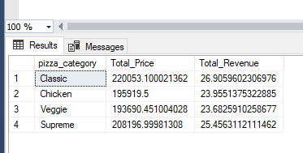OUTPUT:

* % of Sales by Pizza Size

Syntax : select pizza_Size,Cast(Sum(Total_price) as decimal(10,2))as Total_Price,

cast(sum(total_price)*100 / (select sum(total_price) from pizza_sale) as decimal(10,2))as PCT from pizza_sale group by Pizza_Size;

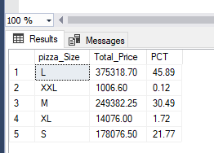OUTPUT:

* Top 5 Best Sellers by Revenue

Syntax : select Top 5 pizza_name, Sum(total_price) as Total_Revenue from pizza_sale group by pizza_Name order by Total_Revenue desc;

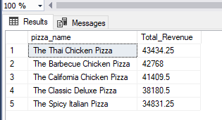OUTPUT:

* Bottom 5 Pizza by Revenue

Syntax : select Top 5 pizza_name, Sum(total_price) as Total_Revenue from pizza_sale group by pizza_Name order by Total_Revenue asc;

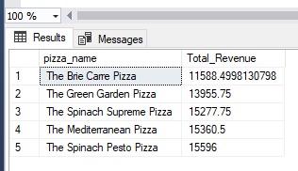OUTPUT:

* Top 5 Pizza by Quantity

Syntax : select Top 5 pizza_name, Sum(Quantity) as Total_Quantity from pizza_sale group by pizza_Name order by Total_Quantity desc;

OUTPUT:

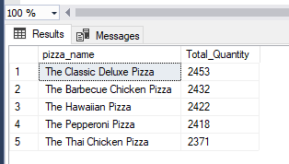

* Bottom 5 Pizza by Quantity

Syntax : select Top 5 pizza_name, Sum(Quantity) as Total_Quantity from pizza_sale group by pizza_Name order by Total_Quantity asc;

OUTPUT:

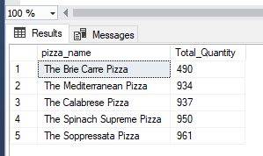

* Top 5 Pizza By Orders

Syntax : select Top 5 pizza_name, Count(distinct(Order_id)) as Total_Orders from pizza_sale group by pizza_Name order by Total_Orders desc;

OUTPUT:

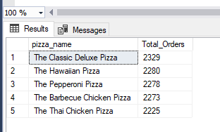

* Bottom 5 Pizza By Orders

Syntax : select Top 5 pizza_name, Count(distinct(Order_id)) as Total_Orders from pizza_sale group by pizza_Name order by Total_Orders;

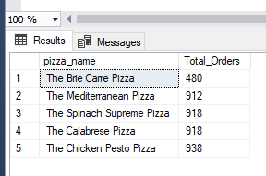OUTPUT: